Lab Objective

Learn how to create and configure Network Policies by using NPS.

**Lab Procedures**

**1.** On RWDC01, using the Network Policy Server, right-click Network Policies, and then click New. The New Network Policy Wizard opens as shown in Figure 13-2.

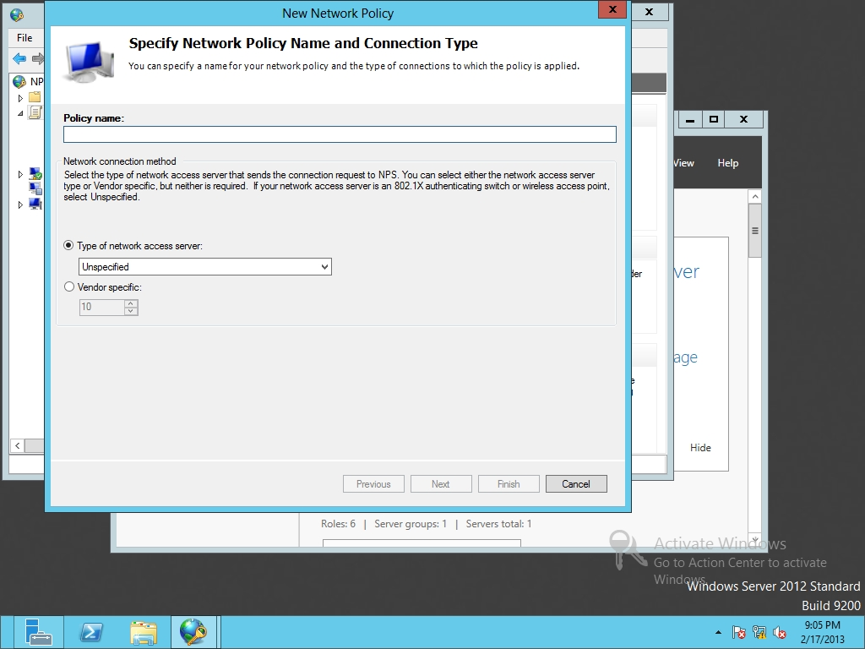

Figure 13-2

Creating a new network policy

**2.** In the Policy name text box, type **Network Policy 1** in the Policy name text box.

**3.** For the type of network access server, select *Remote Access Server (VPN-Dial up)*. Click Next.

**4.** On the Specify Conditions page, click Add.

**5.** When the Select conditions dialog box opens, click Windows Groups and click Add.

**6.** Click Add Groups. In the Enter the object name to select text box, type **domain guests** and click OK. Click OK to close the Windows Groups dialog box. Click Next.

**7.** On the Specify Access Permission page, answer the following question, and click Next.

**8.** On the Configure Authentication Methods page, take a screen shot by pressing Alt+Prt Scr and then paste it into your Lab13_worksheet file in the page provided by pressing Ctrl+V. Click Next.

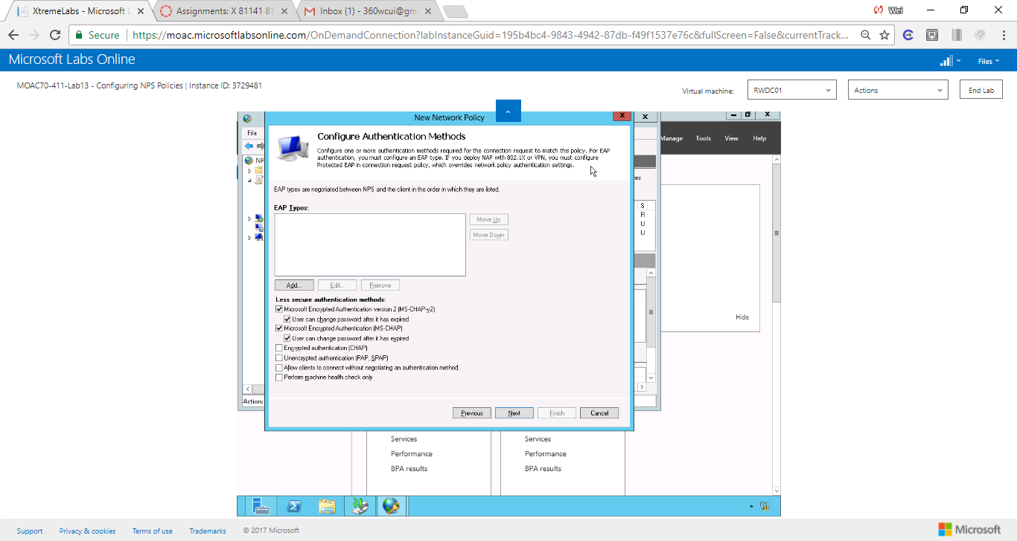

Figure Screenshot shows Configure Authentication Methods page

**9.** On the Configure Constraints page, with Idle Timeout selected, select the *Disconnect after the maximum idle time*. Then specify 15 minutes. Click Next.

**10.** On the Configure Settings page, click Next.

**11.** On the Completing New Network Policy page, click Finish.

**12.** Click Network Policies under Policies on left side and observe that the new Network Policy 1 is listed in the Network Policies pane.

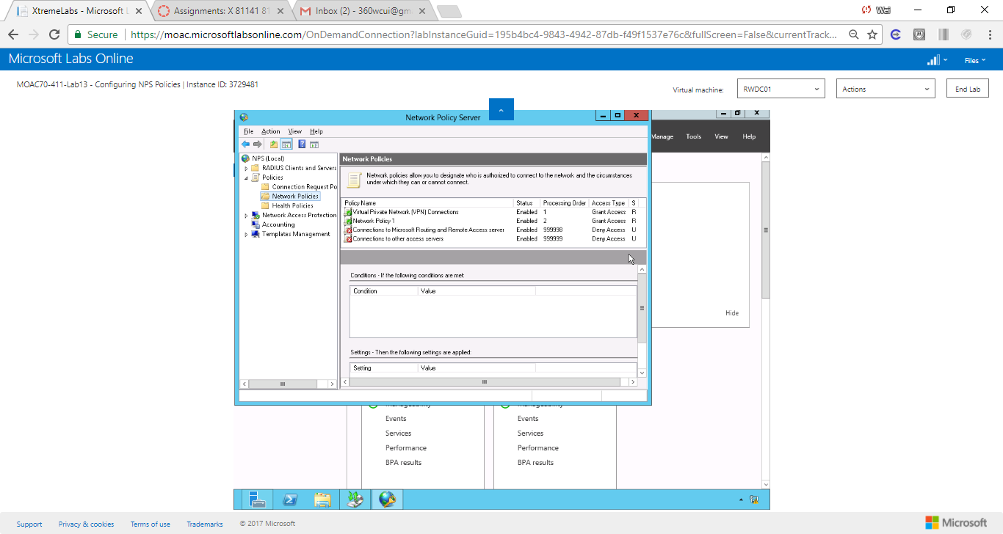

Figure Screenshot shows Network Policy 1 is listed in the Network Policies pane

**Lab Summary**

During this exercise, I continued to use NPS policies by creating and configuring Network Policies. Network policies establish sets of conditions, constraints, and settings that specify who is authorized to connect to the network and the circumstances under which the user can or cannot connect. By default, the default access permission is access granted. Connection requests, network policies and health policies are three components that make up a NPS network policy.